**DAILY ONLINE ACTIVITIES SUMMARY**

|  |  |  |  |  |  |  |  |  |
| --- | --- | --- | --- | --- | --- | --- | --- | --- |
| **Date:** | **05/07/2020** | | | | | **Name:** | **NAIPUNYA VINOD NAIK** | |
| **Sem & Sec** | **IV SEM & A SECTION** | | | | | **USN:** | **4AL18CS050** | |
| **Online Test Summary** | | | | | | | | |
| **Subject** | | **NO INTERNALS CONDUCTED** | | | | | | |
| **Max. Marks** | | **----------------------------** | | **Score** | | | **-----------------------** | |
| **Certification Course Summary** | | | | | | | | |
| **Course** | **1) PROGRAM FLOW IN JAVA**  **2) CYBER SECURITY IN 90 MIN**  **3) WEBINAR ON HOW TO BECOME A DATA SCIENTIST** | | | | | | | |
| **Certificate Provider** | | | **1) UDEMY**  **2) UDEMY**  **3) ORACLE** | | **Duration** | | | **1) 35 MIN**  **2) 1.5 HR**  **3) 1 HR** |
| **Coding Challenges** | | | | | | | | |
| **Problem Statement: ---------------------------------------------------** | | | | | | | | |
| **Status:--------------------------------** | | | | | | | | |
| **Uploaded the report in Github** | | | | | **YES** | | | |
| **If yes Repository name** | | | | | <https://github.com/naipunya-naik/daily-progress-report>  <https://github.com/naipunya-naik/lockdown-certification-course-dates> | | | |
| **Uploaded the report in slack** | | | | | **YES** | | | |

Online Test Details: (Attach the snapshot and briefly write the report for the same).

NO INTERNALS CONDUCTED

Certification Course Details: (Attach the snapshot and briefly write the report for the same).

CERTIFICATION COURSE NAME:- PROGRAM FLOW IN JAVA

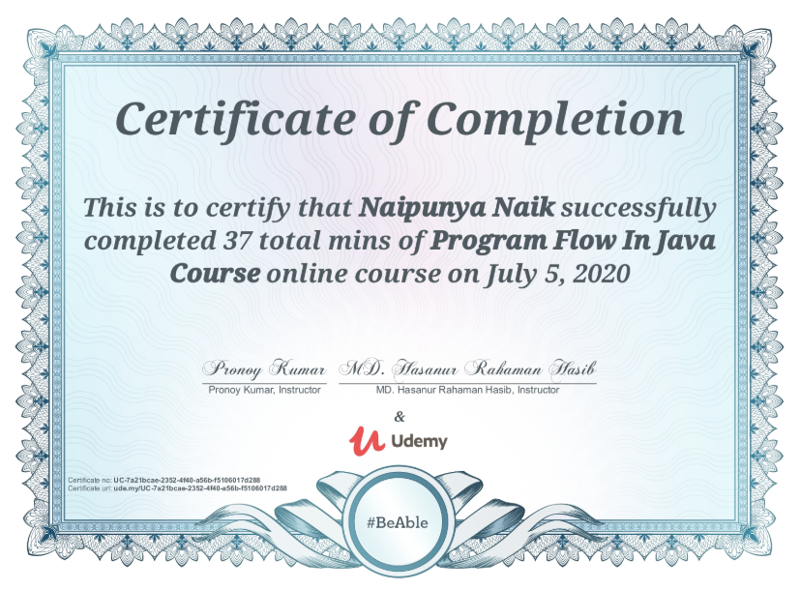

TOPICS LEARNT ON JULY 5, 2020

* Making the Most of Variables and Their Values
* Controlling Program Flow with Decision-Making Statements
* Controlling Program Flow with Loops

CERTIFICATION COURSE NAME:- CYBER SECURITY IN 90 MIN

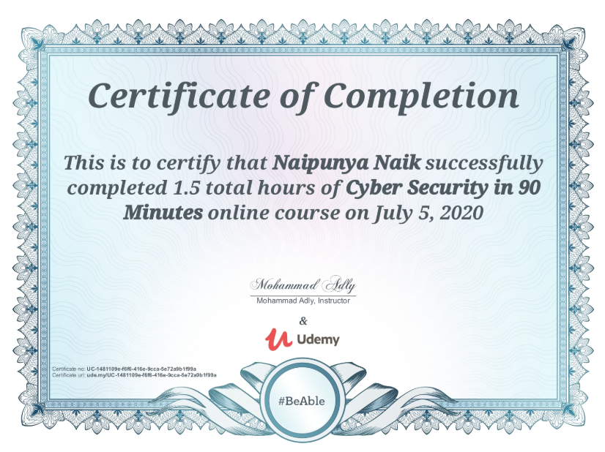

TOPIC LEARNT THROUGHOUT THIS COURSE ON 05 JULY 2020:-

* To setup a secure base for their IT environment and review an existing one as well.

3) WEBINAR ON HOW TO BECOME A DATA SCIENTIST? WHAT IS DATA SCIENCE

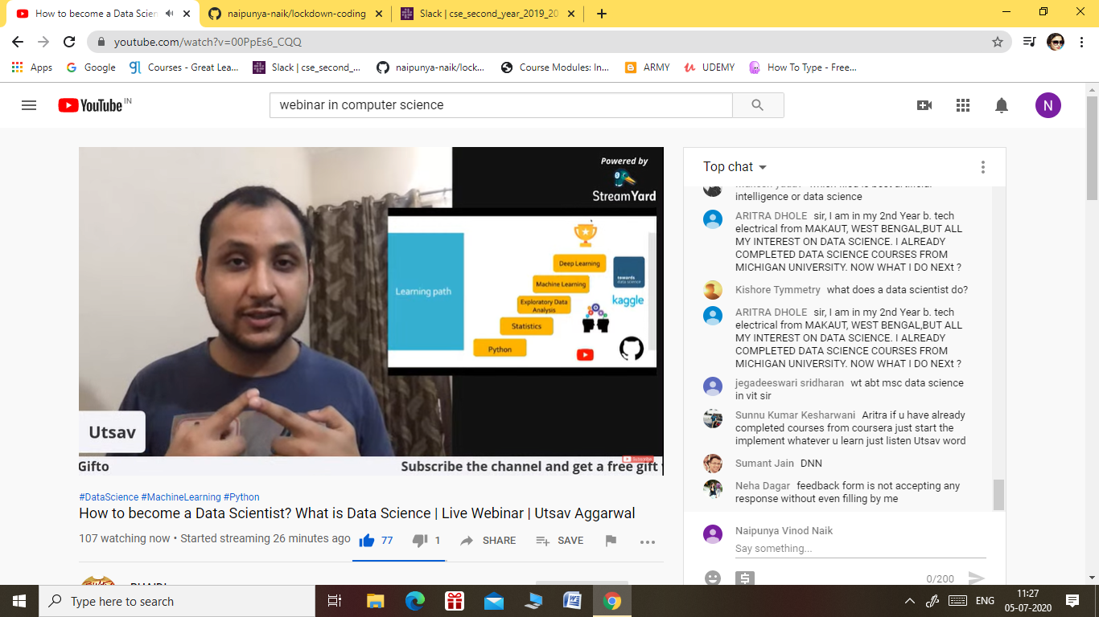

CONDUCTED BY:- UTSAV AGGARWAL, SENIOR DATA SCIENTIST , ORACLE

**DURATION:- 1 HR**

**FROM 11 AM TO 12PM**

**BELOW IS THE WEBINAR CERTIFICATE**

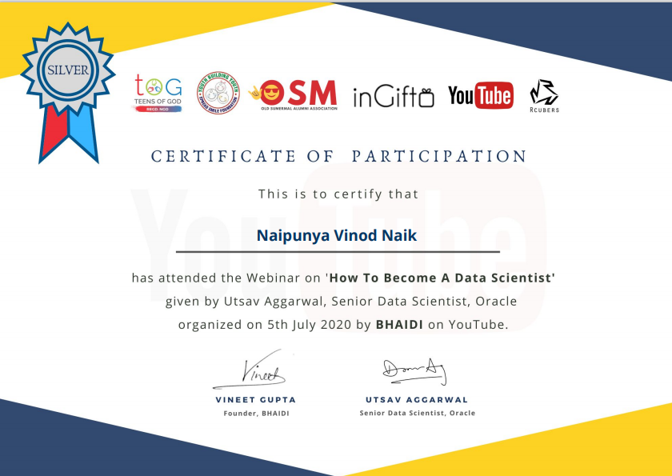

Coding Challenges Details: (Attach the snapshot and briefly write the report for the same).

NO PROBLEM STATEMENTS GIVEN TODAY